Melkus AGVs speak VDA 5050

Standardised interface enables smooth mixed AGV operation: As they comply with the VDA 5050 standard, Melkus Mechatronic's automated guided vehicles (AGVs) can be quickly and easily integrated into existing driverless transport systems. Likewise, VDA5050-compatible vehicles from other manufacturers can be used in Melkus Mechatronic systems. This multi-vendor solution facilitates heterogeneous AGV fleets, providing customers with ample opportunity for high-level cherry-picking.

Goeming/Salzburg, 27.10.2025 – Making it easier to control complex production chains. driverless transport systems have been a central component of modern intralogistics for some time. Facilitating an efficient collaboration of vehicles from different manufacturers requires a common language. This is what the VDA 5050 standard provides. The open interface standardises communication between the master controller and the vehicle and yields numerous advantages.

What is VDA 5050?
The interface has been developed by the German Association of the Automotive Industry (VDA) and the German Engineering Federation (VDMA). It standardises the exchange of transport orders, status messages and driving information. Instead of using various proprietary protocols, every vehicle communicates with every control system using a unified language based on cutting-edge technologies such as MQTT and JSON. This facilitates interoperability, reduces integration costs and ensures long-term viability.

An AGV and software specialist
Melkus Mechatronic AGVs run on continuously developed proprietary vehicle software, enabling Melkus to respond swiftly to extension requirements or customer requests. The Sigmatek TCS (Traffic Control System) master control system plans, prioritises and distributes transport orders, controls traffic and monitors vehicle status. Using VDA 5050 also allows orchestrating multiple vehicle types within a heterogeneous fleet. This makes it easy to implement mixed-vehicle systems, ensuring the efficient implementation of complex production chains.

"For our customers, VDA 5050 opens up completely new degrees of freedom in the design of their internal logistics," explains Martin Lindner, managing director of Melkus Mechatronic. "Our vehicles can be easily integrated into existing systems, regardless of the control system or the types of vehicles used. This makes our AGVs particularly future-proof."

Flexibility and independence

The use of VDA 5050 brings greater flexibility to operators of AGV systems. Standardised communication enables rapid integration of AGVs. The simplified addition of new AGVs to existing fleets, even at a later date, improves the scalability and investment security of the systems, as it enables rapid system expansions to increase productivity.

Melkus Mechatronic offers a wide range of AGVs: from the ultra-compact C4060 to the flat F52 platform AGV to pallet AGVs such as the HLG120 with a load capacity of 1,300 kg. The Melkus range also includes special vehicles such as the Melkus Rack Stacker that was developed specifically for electronics and precision mechanics manufacturing. The range covers all common use cases. Thanks to VDA 5050, it can be seamlessly expanded with AGVs from other manufacturers if required. Likewise, Melkus AGVs can also be smoothly integrated into mixed systems via the standardised interface.

Complying with the VDA 5050 standard, Melkus Mechatronic enhances its position as a leading technology provider on the European AGV market. By combining its own vehicle software, modular architecture and standard-compliant communication, the company offers a future-oriented solution for automated material flows in industry and logistics.
Image Captions

The Melkus AGV range is diverse and covers all common use cases. Its modular architecture, in-house developed vehicle software and standardised communication via VDA 5050 ensure future-orientation and investment protection.  All images, unless otherwise stated:  Melkus Mechatronic. | 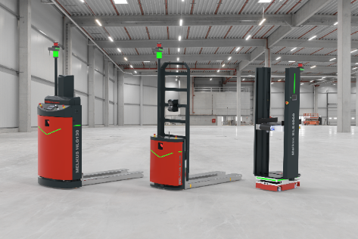
The VDA 5050 interface facilitates seamless mixed operation with AGVs from Melkus Mechatronic and other manufacturers within a heterogeneous fleet.  Graphics: | 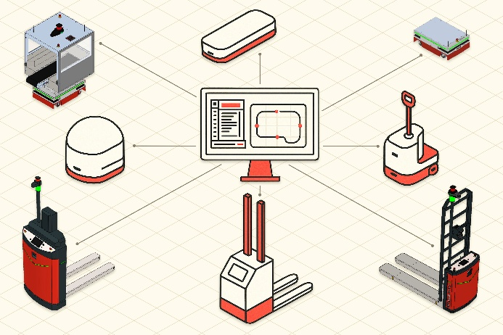
Martin Lindner, CEO, Melkus Mechatronic:  "For our customers, VDA 5050 opens up completely new degrees of freedom in the design of their internal logistics. Our AGVs can be easily integrated into existing systems, regardless of the fleet management system or vehicle types already in use. This makes our AGVs particularly future-proof."  Photo: A. Glier | 

About Melkus Mechatronic
Melkus Mechatronic GmbH is an innovative technology company based in Salzburg. With more than ten years of experience in the field of AGVs and mobile robotics, it provides customers with highly available AGVs for flexible in-house transport with maximum reliability. Swiftly installed and commissioned, these enable Melkus operators to organise their intralogistics more efficiently and to establish resource-saving processes. Melkus employs highly qualified and committed staff and offers a range of six AGVs for a wide variety of applications. www.melkus-mechatronic.com

